Maybe at the end… there’ll be a**-** never mind, that’ll be a surprise. 😏

So, how this works, is that I will show you a couple photos, and you will choose through them, I will tell you something about each one. Whatever I tell you, is going to be important, & can help you improve your skills.

Hi! I’m Koko the Koala & I am going to help you throughout this game. This game is going to help you get better at photography.

Congratulations

🏆

🏆

Anyway…

I’m going to help you out, here are some tips…

* Press the up arrow to avoid enemies 🛑 **↑**
* Press the up arrow to get prizes 🏆↑

😮 One more thing, you might get an enemy later, so… just watch out for them… if they come toward you, just jump to avoid them

**GAME OVER**

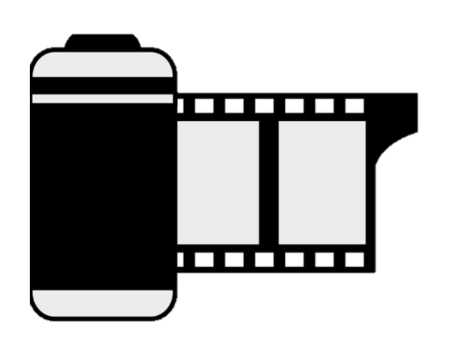

N  
 e  
 x  
 t

